Abdullah Dej, robotics engineering student
Id;9230353006

HT-8A Radio Transmitter and Receiver System

1. Introduction
The HT-8A radio transmitter and receiver system is a multi-channel remote control solution designed for unmanned systems such as multirotor drones. It provides reliable wireless communication between the ground control station (pilot) and the airborne platform, enabling precise control of flight functions and real-time signal feedback. The system consists of two main parts: the handheld transmitter and the onboard receiver, which together form the core command-and-control link of the unmanned aerial vehicle (UAV).

2. System Overview
The HT-8A system operates using a digital radio communication protocol that allows stable signal transmission, configurable channels, and fail-safe protection. The transmitter features multiple joysticks, switches, and a display interface for configuration and monitoring. The receiver is compact, lightweight, and designed to be integrated directly into the drone’s control system, distributing control signals to the flight controller.

2.1 Transmitter Unit
The transmitter is ergonomically designed for manual operation and includes:
- Dual control joysticks for primary flight inputs
- Multiple auxiliary switches for mode selection and additional functions
- An integrated display for channel monitoring, voltage status, and configuration
- Model memory for storing multiple configuration profiles
The transmitter allows fine adjustment of channel direction, travel limits, neutral points, and mixing functions, making it suitable for complex multirotor control requirements.
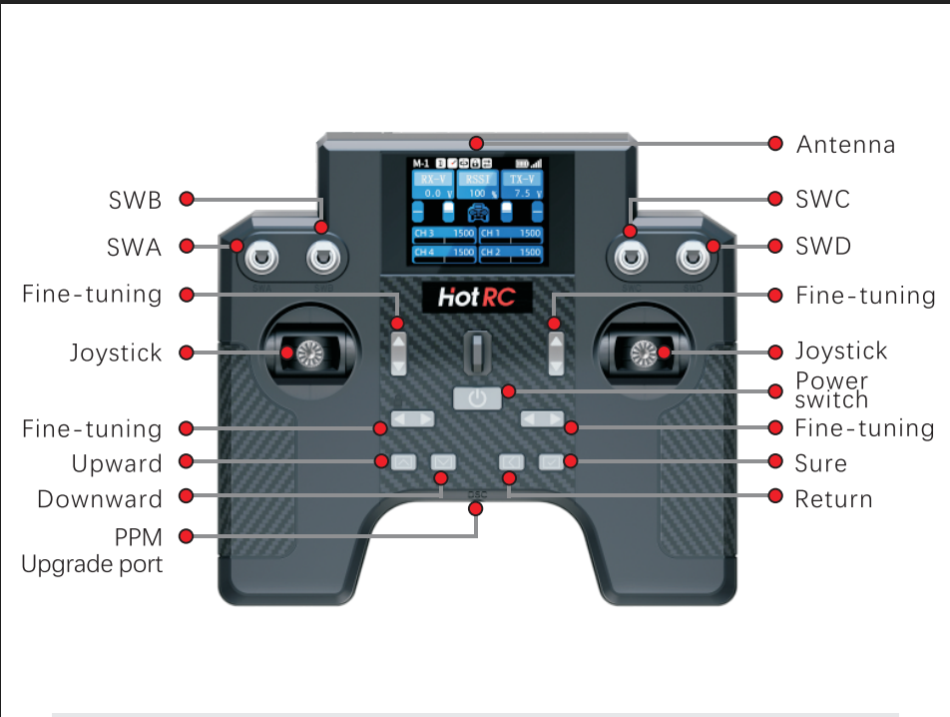

2.2 Receiver Unit
The HT-8A receiver is responsible for receiving radio signals from the transmitter and converting them into control outputs. Key characteristics include:
- Multiple output channels for connection to a flight controller
- Stable operating voltage suitable for UAV electronics
- Signal indicator LEDs for status monitoring
- A binding (frequency matching) button for pairing with the transmitter
The receiver is designed for low latency and stable signal output, which is critical for maintaining safe and responsive flight behavior.
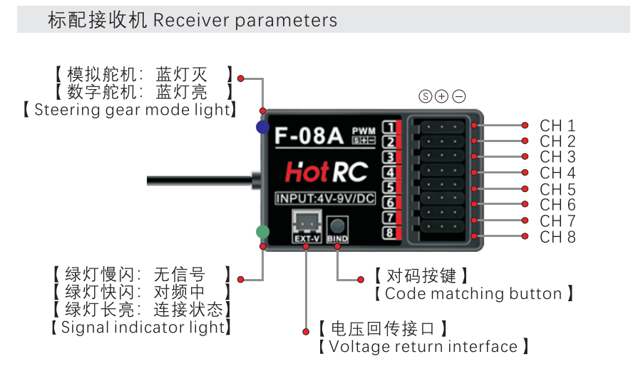

3. Operating Principles
The transmitter sends encoded control signals over a radio frequency link. These signals are received by the onboard receiver, decoded, and output as standard control signals to the flight controller. The system supports channel mapping, direction reversal, endpoint adjustment, and fail-safe configuration to ensure predictable behavior under normal and abnormal conditions.
Binding is required before first use, ensuring that the transmitter and receiver operate exclusively as a matched pair, reducing the risk of interference from other radio systems.
4. General Usage Instructions
- Power on the transmitter.
- Supply power to the receiver through the UAV’s power system.
- Perform the binding process to establish communication between the transmitter and receiver.
- Verify channel outputs and ensure correct response to joystick and switch inputs.
- Configure channel mapping and fail-safe behavior as required.
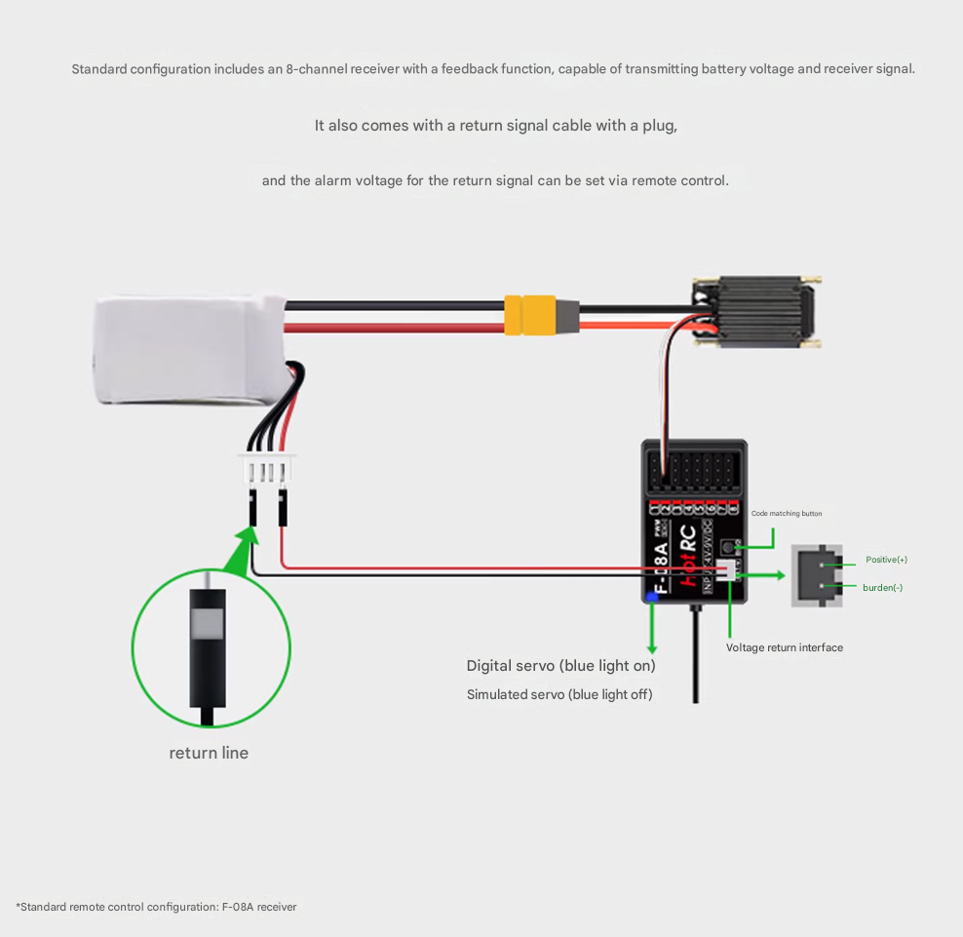
Before operational use, it is essential to test all control inputs on the ground to confirm stable communication and correct signal direction.

5. Integration and Function with Our UAV
Within our unmanned aerial vehicle, the HT-8A transmitter and receiver system functions as the primary command interface between the operator and the drone. The transmitter allows the pilot to send real-time control commands such as throttle, attitude adjustments, and mode switching. These commands are wirelessly transmitted to the onboard receiver.

The receiver, installed securely inside the UAV frame, outputs the received control signals directly to the flight control system. This enables the flight controller to interpret pilot commands accurately and translate them into motor and control surface responses. The reliability of the HT-8A link ensures stable manual control, safe arming and disarming procedures, and dependable operation during all phases of flight.

6. Conclusion
The HT-8A radio transmitter and receiver system is a critical component of the UAV control architecture. Its stable communication link, flexible configuration options, and reliable signal handling make it well-suited for multirotor drone applications. When properly configured and integrated, the system provides precise control, enhances operational safety, and serves as a dependable interface between the human operator and the unmanned aircraft.

